Chapter 1 Problem 21 Michael Streyle

##   
## Call:  
## lm(formula = broken ~ route)  
##   
## Coefficients:  
## (Intercept) route   
## 10.2 4.0

## (Intercept)   
## 14.2

## (Intercept)   
## 18.2

## (Intercept)   
## 4

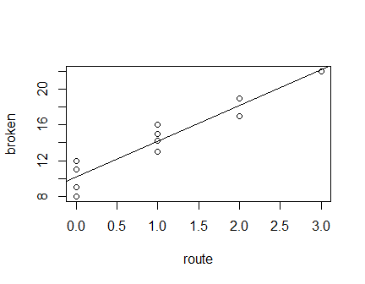

The intercept is 10.2 broken ampules and the slope is 4 broken ampules per route.

Written Answers to Question 21

1. The estimated regression function is Ŷ = 10.2 + 4(X). The linear regression line does seem to give a good fit here – the line follows the data very well.
2. The point estimate of the expected number of broken ampules when X = 1 is 14.2.
3. When there are two transfers made, the expected number of broken ampules is 18.2 so the difference between one transfer and two transfers is 4.0.
4. By plotting the point ($\overline{X}, \overline{Y}$) on the plot of the data and best fit line, it shows the point is on the fitted regression line. See below in red.

